Tyler Wiggins

CST-247

Bill Hughes

4/18/2021

GitHub Link with all the code: <https://github.com/FLAME270/Bible_Benchmark_assighnment.git>

Loom video link:

Part 1: <https://www.loom.com/share/4415729aff694a18983a25e6bd3a998e>

Part 2: https://www.loom.com/share/14ab2cb55b024e6695e5e354670943a3

Part 3: <https://www.loom.com/share/0549a664ac5a4f91ba4b9fe43d632c47>

Database file provided in GitHub

Design report:

First, we made 2 model classes “BibleVerse.cs and VerseSearch, these classes stored all the variables needed to search a Bible verse. Then we made a database that had all the Bible versions, chapters, verses, genre and inputed it into a Microsoft SQL Server. The next step we did was make the “BibleData” class that acted as a middleman to communicate with the database. We then made a “BibleBusinessService” with a GetAllVerses method that connects the controller and DAO. Then we made the BibleController, a class that sends data to the views and get the searchResults from the DAO. We then made a Index view that has all the front end that allows the user to search for a Bible verse. The very last thing we did was make a _Layout.cshtml file that communicated with the javascript and the css that we added to the index page.

ER diagram:

John 3:16 Search Screenshot:

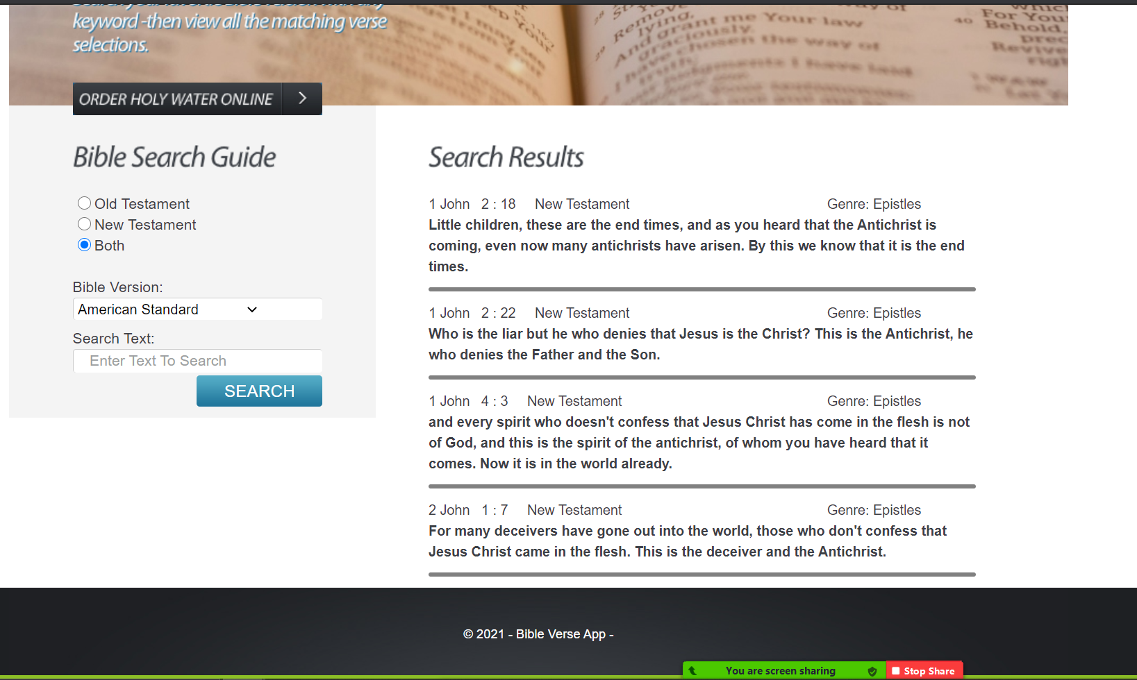

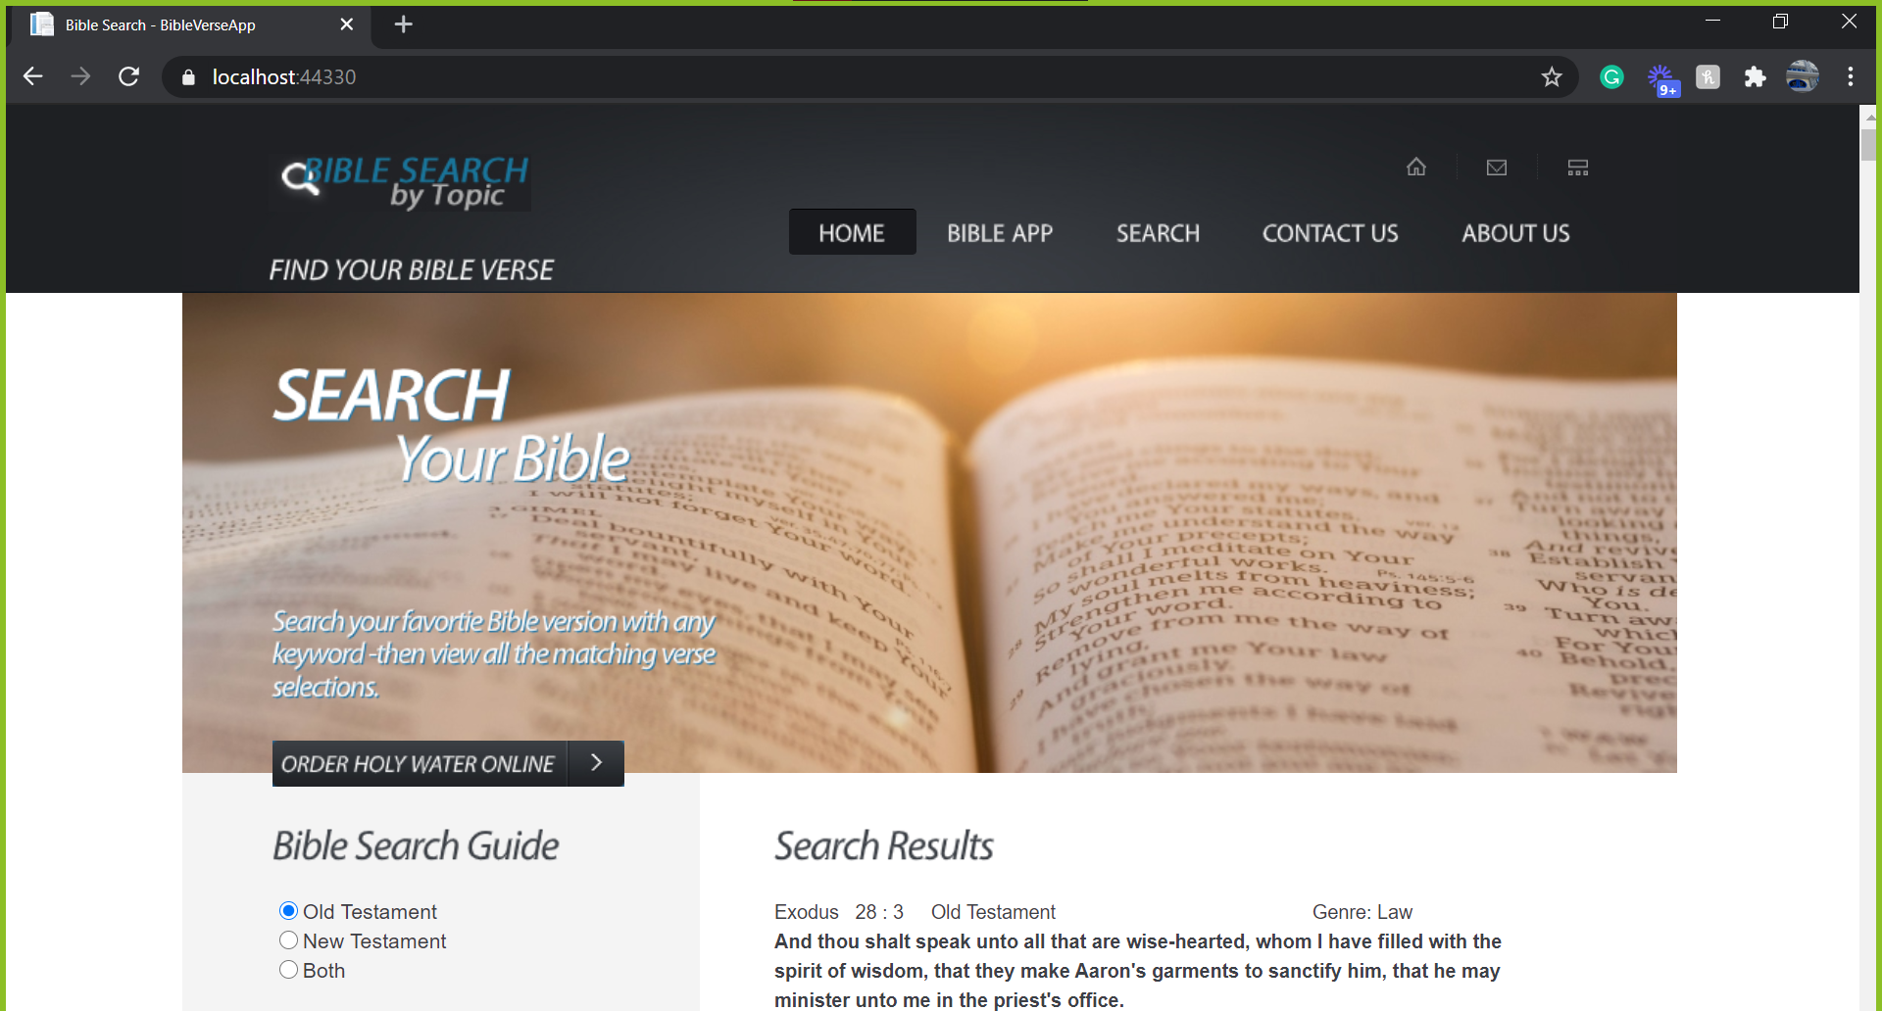

Verse of the Day Feature:

There are many ways we could implement a Bible verse of the day feature, but the easiest way to implement it is by using an already existing api. King James Bible Online is a website that has a free to use verse of the day API, with all the documentation needed to implement such an amazing feature within the Bible application.

They make using their API incredibly easy, simply add this line of code in the html/View page exactly were you want the verse to be.

<script type="text/javascript">

document.write("<iframe src=\"https://www.kingjamesbibleonline.org/popular-bible-verses-widget.php\" style=\"width: 200px; height: 240px; border: 0px solid #ffffff;\"></iframe>");

</script>

Source: https://www.kingjamesbibleonline.org/Add-Bible-to-Your-Website.php

The api changes the verse every day and you can visit your bible app knowing that you will learn something new every day. Another way we could implement a Bible verse of the day, is by getting the date and time, then use a random number generator to randomly a new Bible verse every time the date changes.

Business Problems:

Many businesses struggle to keep up with technology, so as developers, we can use the tools and knowledge we know to make websites and applications that will help older business owners reach out to the young people that mostly learn from technology. Mark 12:31 says “Thou shalt love thy neighbor as thyself”, as a programmer, I could use my programming skills to help others the way I would want someone to help me. Some people cannot afford to buy a Bible, so as a developer, we can provide someone with an online Bible, so they can seek God without the financial hassle of paying $15-$80 for a Bible. I could also develop API’s that can help make people’s lives easier and help them with tasks that could otherwise be a challenge to them. There are many ways that programming can help those around you and provide solutions the many problems that exists in our society today.